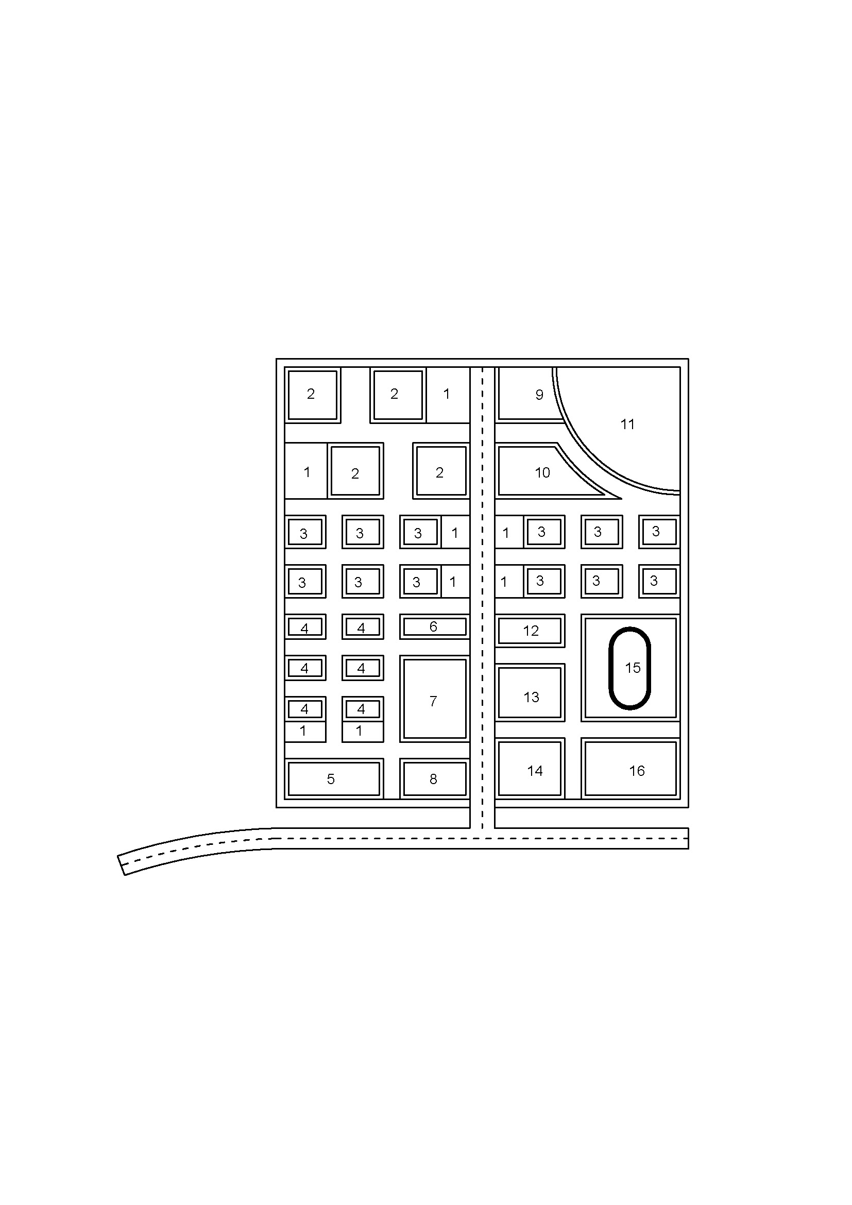

Scale – 1:250

Layout of the Plot

**Legends:**

1 – Plantation

2 - Apartment

3 - Villa

4 - Bungalow

5 – Open Space

6 – Open Space

7 – Super Market

8 – Security Office

9 – Sewage Treatment Plant

10 - Garden

11 – Water storage Area

12 - Dispensary

13 – Community Hall

14 – Parking Lot

15 - Playground

16 – Indoor Sports Complex

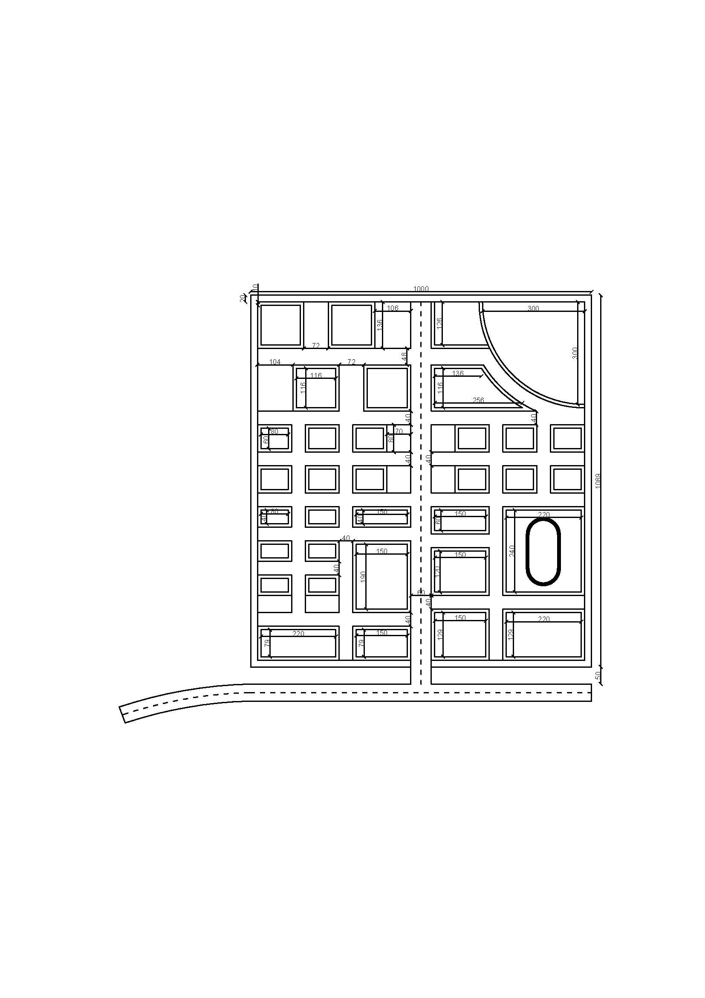

**Dimensional Layout**

**Scale – 1:250**

**All dimensions in “inches”.**